**EXPERINMENT 4**

**Aim :** To study Histogram Equalization and Histogram Matching.

* **Exercises :**

1. **Can two visually different image have same histogram? If yes, synthesize two grayscale images which are visually different but having same histogram and also show the histogram. If no, justify your answer.**

* **Solution :-**
* Histogram is not a unique representation of an image.
* Histogram is a graph of gray value vs frequency of occurrence of gray value. It depends on the probability or frequency of gray value.
* So ,no matter how the gray values are distributed over the image, if the frequency of occurrence of gray value is not changed, the histogram will not change .Therefore, Histogram is not unique representation of images.
* That means it is possible that two or more different images can have same Histogram.

Code :

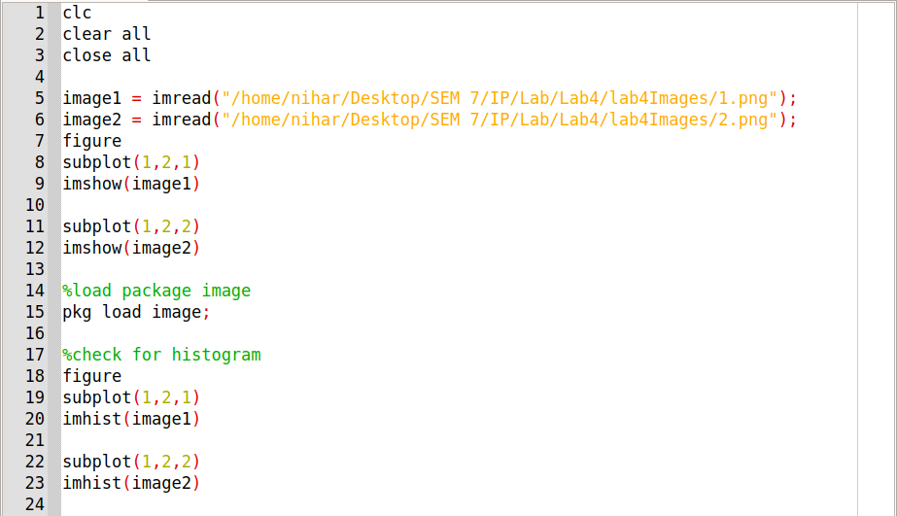

Input Image :

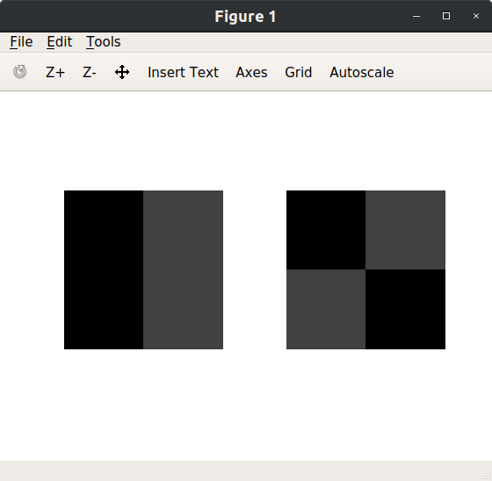

Output Image :

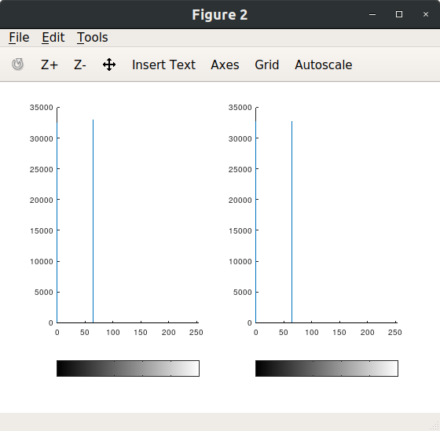

1. **Take your color photograph taken in dark. Equalize it’s histogram.**

* **Solution :-**

MyHistEqualizer Function :

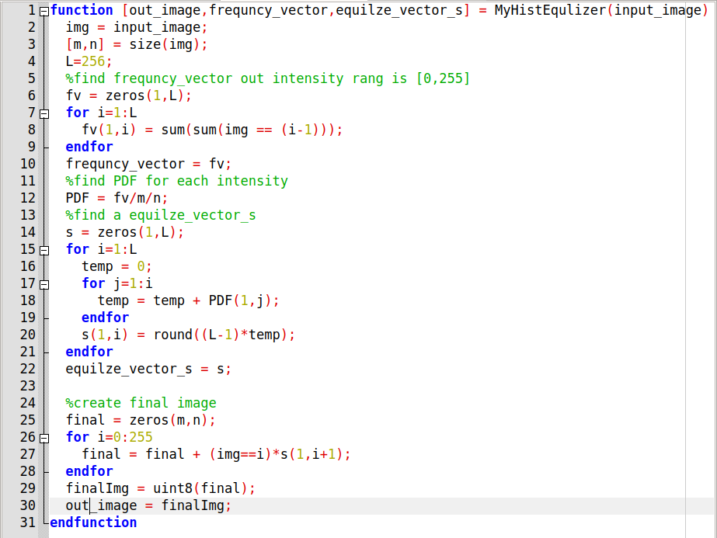

Code :

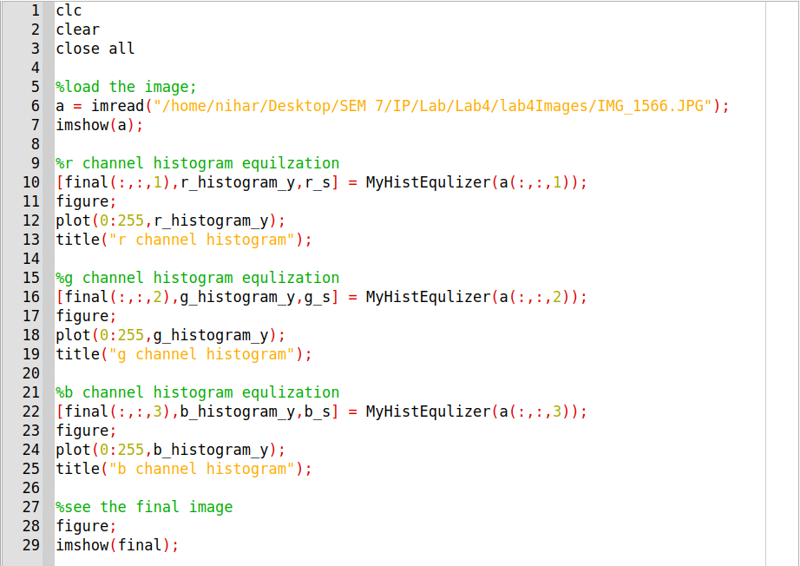

Input Image :

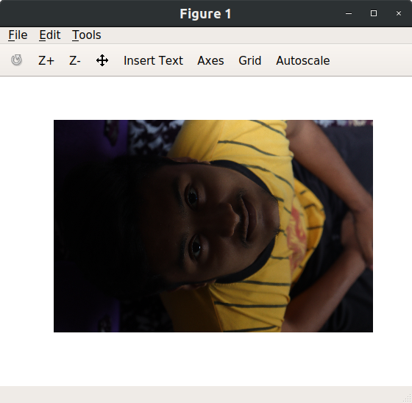

Output Images :

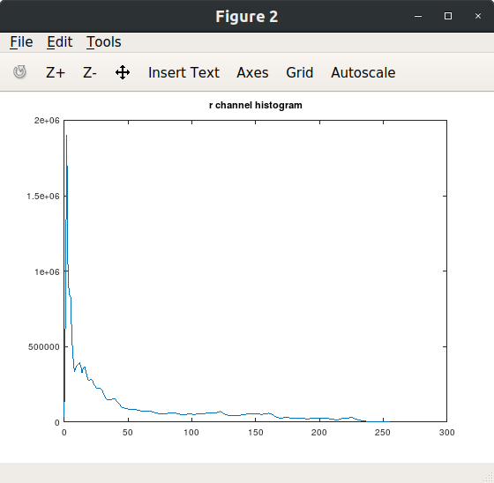

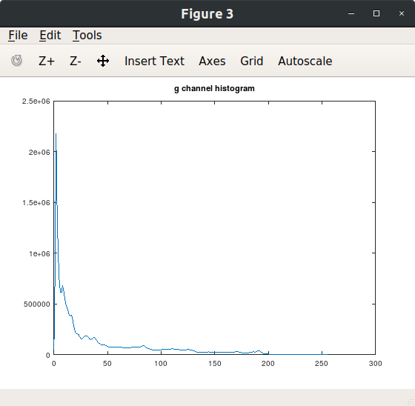

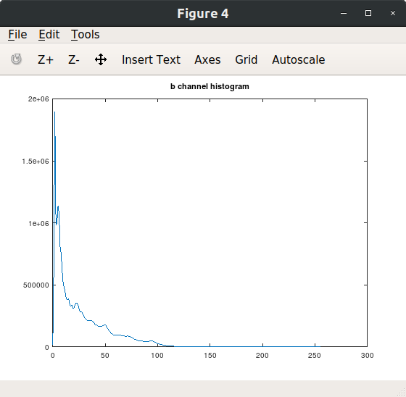

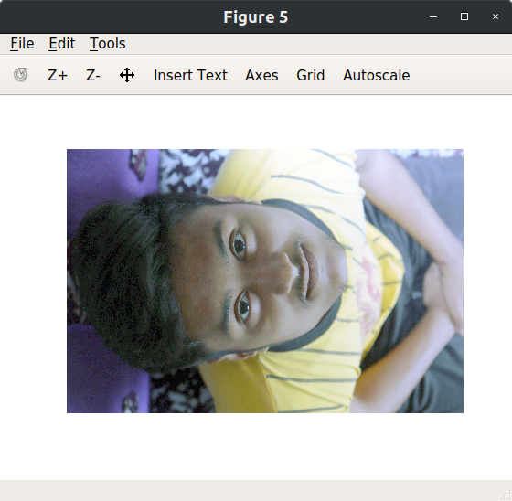

1. **Perform histogram equalization of equalized image obtained. Is second pass of the histogram equalization process useful? Justify your answer.**

* **Solution :-**
* If histogram equalization is applied twice, there is no change. This is because a histogram equalization is idempotent.

Code :

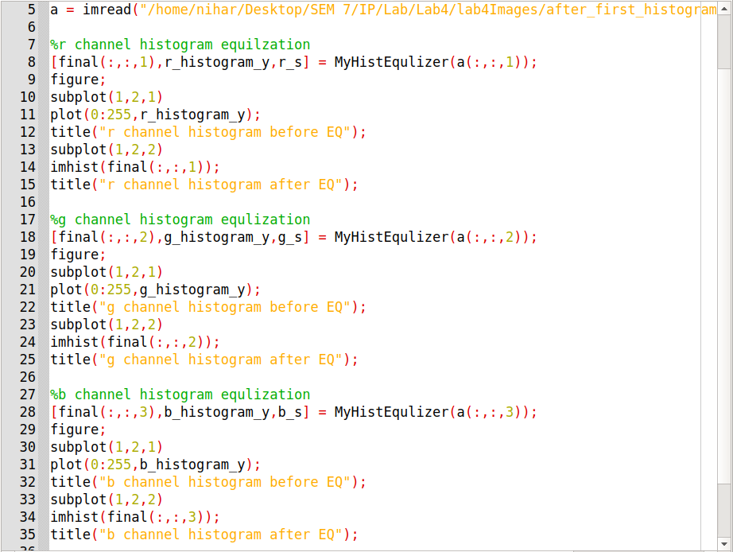

Comparision of histograms (before and after second equalization) :

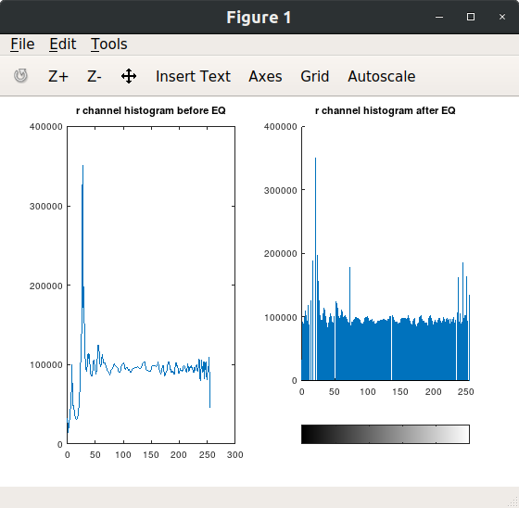

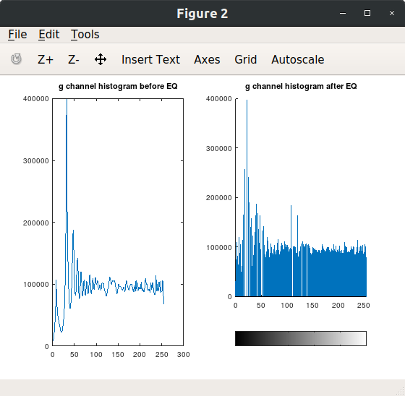

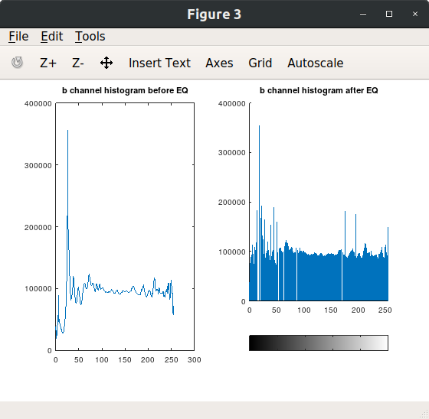

1. **Perform histogram equalization for image ‘test3.jpg’**

* **Solution :-**

Code :

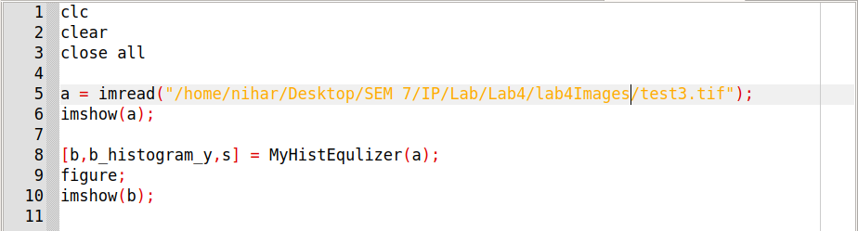

Input Image :

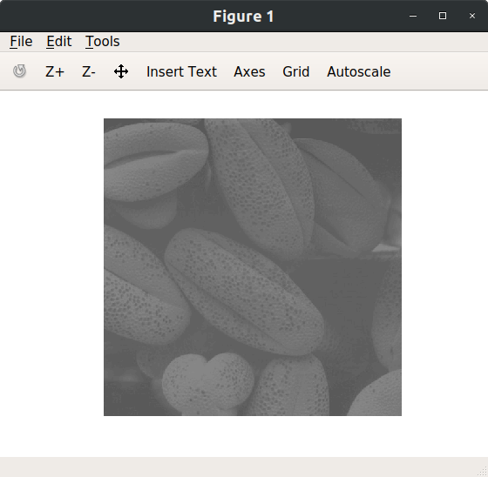

Output Image :

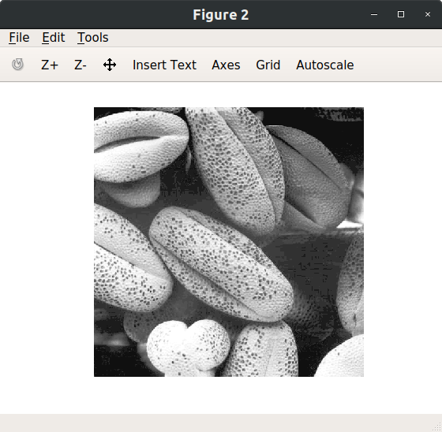

1. **Take any of your photograph, match it’s histogram with the histogram of image ‘test4.jpg’. plot histogram of original image, template and matched image for all three channels.**

* **Solution :-**

MyHistMatcher Function :

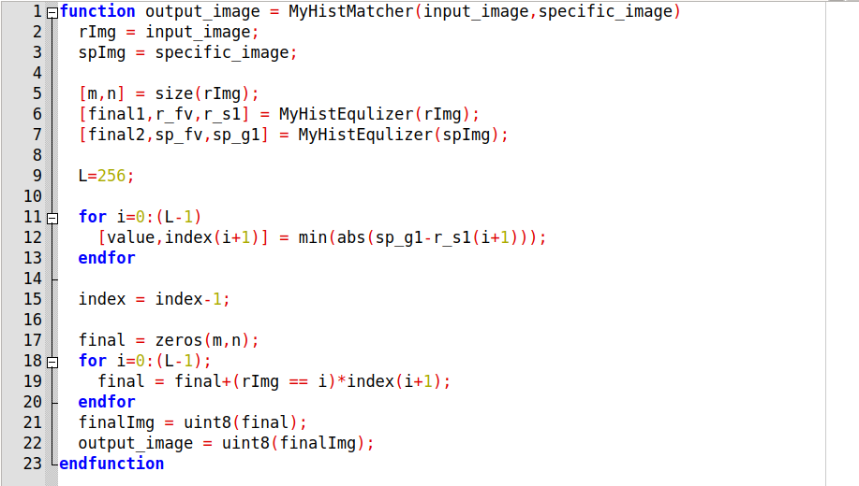

Code :

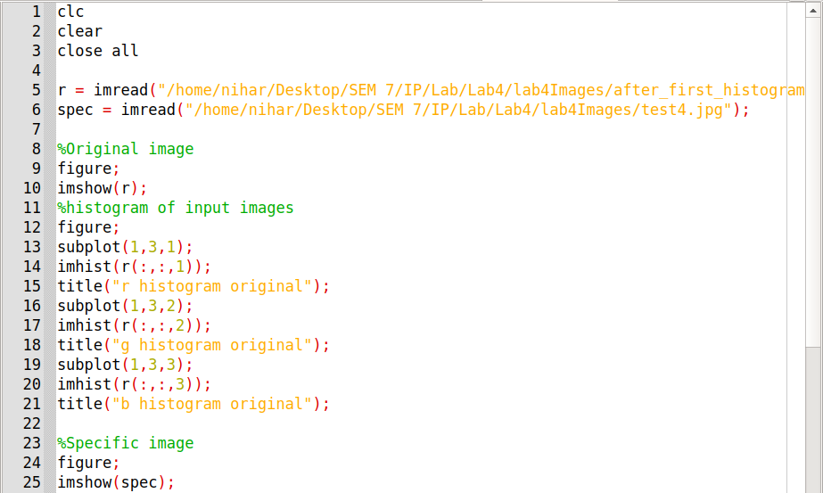

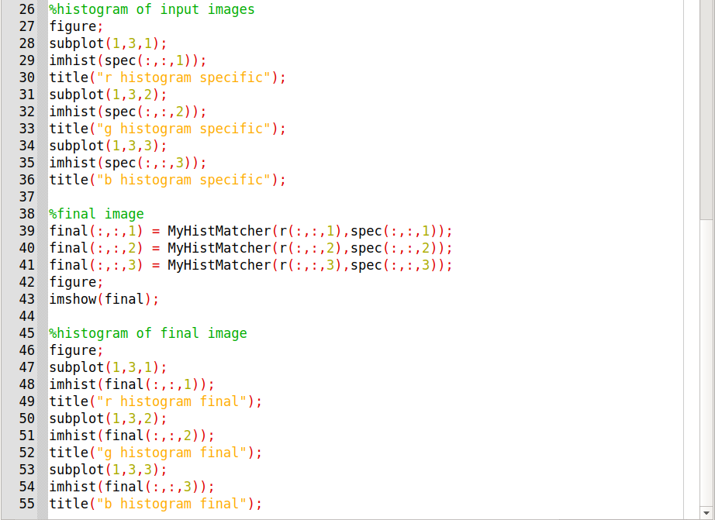

Input Image :

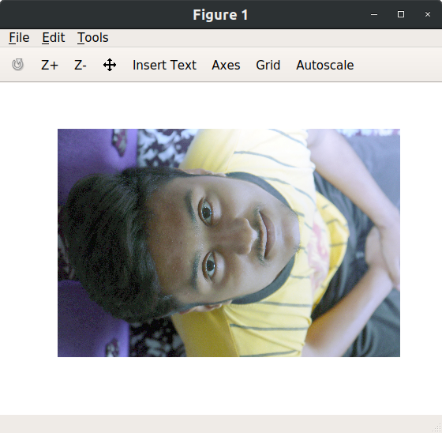

Histogram of Input Image :

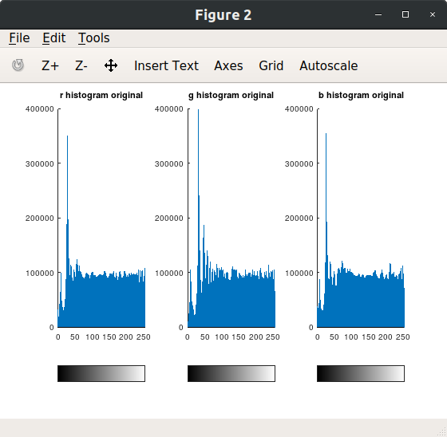

Specified Image :

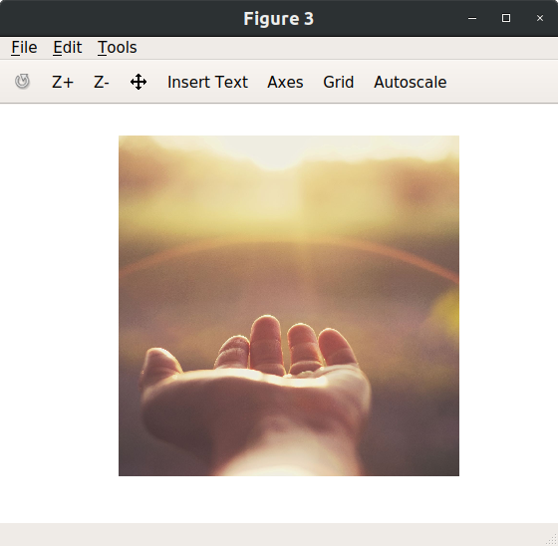

Histogram of specified Image :

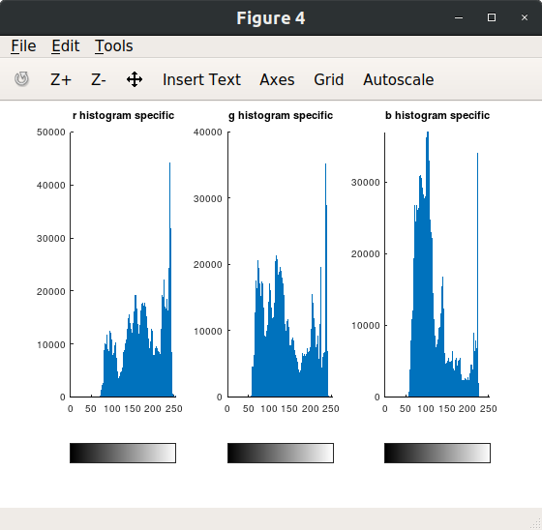

Output Image :

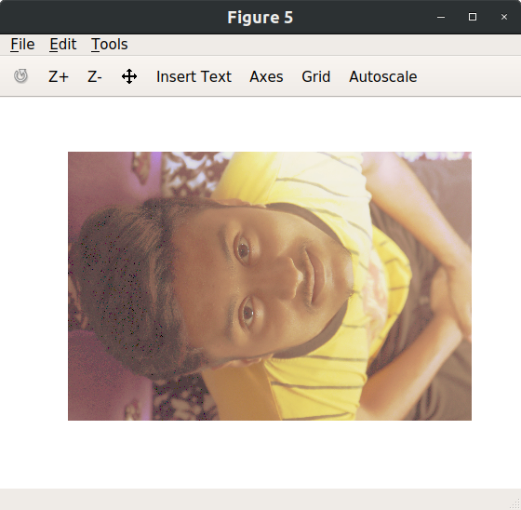

Histogram of Output Image :

